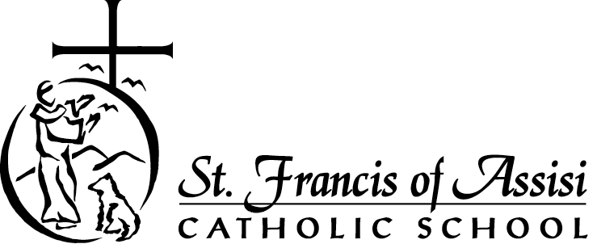
August 2021

POSITION OPENING: 5th Grade Teacher

St. Francis of Assisi Catholic School, a Preschool - 8th grade school in Yorba Linda, is seeking a dynamic, experienced, and faith-filled elementary teacher who, as an effective educator, demonstrates thorough curriculum knowledge, can teach and assess effectively, take responsibility for professional growth, and creates a class environment that fosters learning and personal growth. As a 5th Grade Teacher, they will teach all subjects, except Music, PE, and Science. This position will serve to support the school's mission and philosophy as a member of a vibrant Catholic school community. The position is for the 2021-2022 school year.

POSITION DESCRIPTION
- 10-month non-exempt with benefits
- Reports to the Assistant Principals and Principal
- Maintain professional attitudes and loyalty to the school at all times. Treat all students, parents, and staff with dignity and respect.
- Responsible for planning, implementing, and assessing 5th grade curriculum
- Adapts curriculum to the needs of the students
- Performs additional duties at the request of the Principal

QUALIFICATIONS
- Prefer a practicing Roman Catholic with a strong commitment to and working knowledge of the Catholic faith
- Diocesan religious certification or willingness to become certified
- Eager to integrate iPad technology in creative, innovative ways to support instruction and student learning
- Strong knowledge of data-driven instruction, curriculum mapping, and teacher-driven learning communities
- Strong knowledge of strategies for engaging students with diverse needs
- Excellent classroom management skills
- Strong interpersonal, collaborative, organizational, and administrative skills

EDUCATION AND EXPERIENCE
- Possess a BA or BS degree and a valid California Teaching Credential
- Minimum 2 years elementary teaching experience

SALARY: Appropriate level on the Diocesan Teacher Salary schedule based on experience and qualifications.

APPLICATION PROCEDURE AND DEADLINE:
Interested and qualified candidates are asked to submit a letter of introduction and resume by email to Mrs. Shannon Kwan at skwan@sfayl.org. or hardcopy to St. Francis of Assisi School, 5330 East Side Circle, Yorba Linda, 92887.

